**Laporan Pengembangan Game Flappycopter**



Disusun oleh:

Deni Gunawan S.

(A11.2019.12026)

Kelompok 4502

**Fakultas Ilmu Komputer**

**Universitas Dian Nuswantoro**

**Tahun 2022**

Daftar isi

BAB I 3

Tentang Game 3

A. Deskripsi 3

B. ScreenShoot 3

BAB II 4

Detail Pengembangan Aplikasi 4

A. Flow chart 4

B. Class diagram 5

C. Screenshoot 6

BAB III 10

Referensi 10

# BAB I

# Tentang Game

## Deskripsi

Game flappycopter ini adalah game yang mirip dengan flappybird namun ada beberapa penyesuaian, seperti adanya level, custom background dan player, highscore dan musik.

Game ini sangat cocok untuk mengisi waktu luang, karna dapat dimainkan dimana saja dan game nya sangat santai. Selain itu tidak ada batasan umur, mulai dari anak-anak hingga orang dewasa tidak ada larangan memainkan game ini.

## ScreenShoot

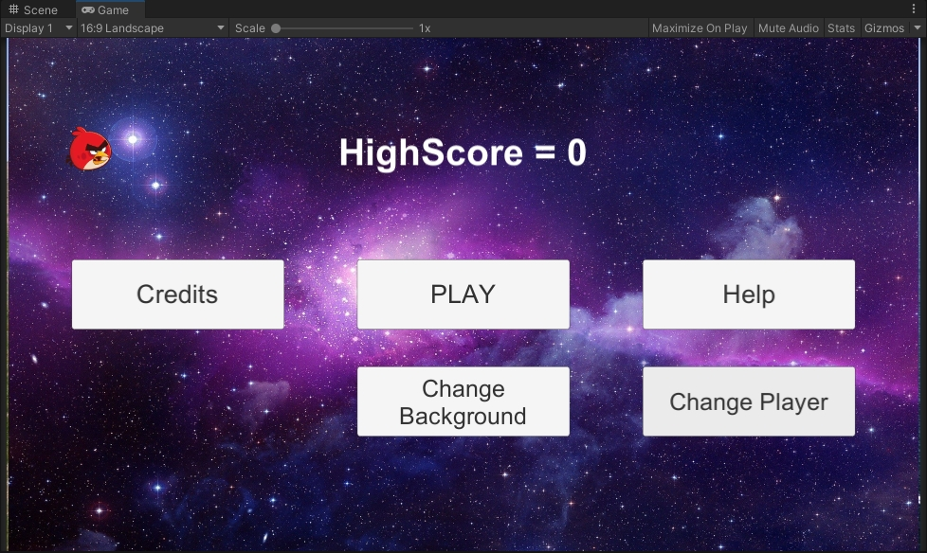

Screenshoot tampilan awal game.

# BAB II

# Detail Pengembangan Aplikasi

## Flow chart

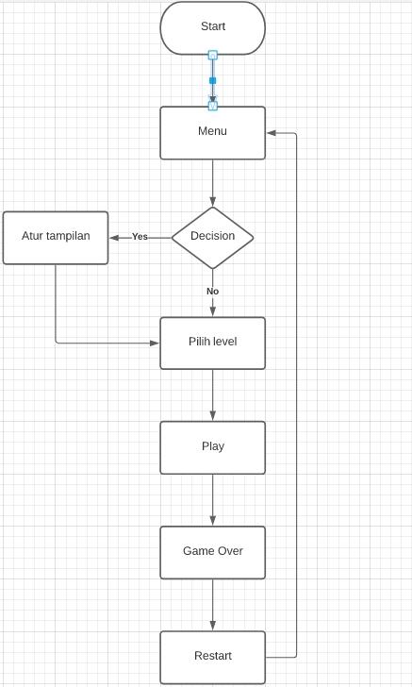

## Class diagram

|  |
| --- |
| Player Control |
| + jumpForce:Vector2  + time:float  - score:int  + guiStyle:GUIStyle  + gameOverText:Text  + scoreText:Text |
| + Update():void  + OnCollisionEnter2D():void  + OnGUI():void  + bonusPoint():void  +tambah():void  +load():void  +Die():void |

|  |
| --- |
| GUI Manager |
| +bgArray:GameObject[]  +playerArray:Sprite[]  +player:Sprite  +indx:int  +indxPlayer:int  +spriteRenderer:SpriteRenderer  +bEasy:Button  +bMed:Button  +bHard:Button |
| +Awake():void  +Start():void  +LoadLevel():int  +saveLevel():void  +LoadButtonLevel():void  +OnCredits():void  +OnHelp():void  +OnBack():void  +OnPlay():void  +OnLevel1():void  +OnLevel2():void  +OnLevel3():void  +changePlayer():void  +getPlayer():void  +changeBackground():void  +getBg():void |

|  |
| --- |
| Save Load High Score |
| +textHighScore:Text |
| +Start():void  +LoadHighScore():int  +SaveHighScore():void  +Update():void |

|  |
| --- |
| Generator Obs |
| +rocks: GameObject  + magnet: GameOnbject |
| +Start():void  +CreateObstacle():void  +CreateMagnetPoint():void |

|  |
| --- |
| Set Background |
| +bgArray: GameObject[]  +spriteRenderer: SpriteRenderer  -indx:int  -player:Player  +playerArray:Sprite[]  -indxPlayer:int |
| +Start():void  +getBg():void  +getPlayer():void |

|  |
| --- |
| Obstacle In Act |
| +veloc:Vector2 |
| +Start():void |

|  |
| --- |
| Musik Manager |
| -instance:MusicManager |
| +Instance():MusicManager  +Awake():void |

## Screenshoot



Screenshoot tampilan awal game

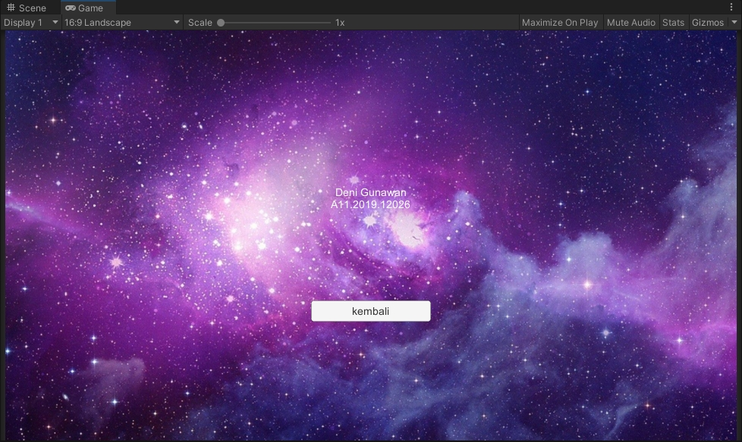

Screenshoot scene credits

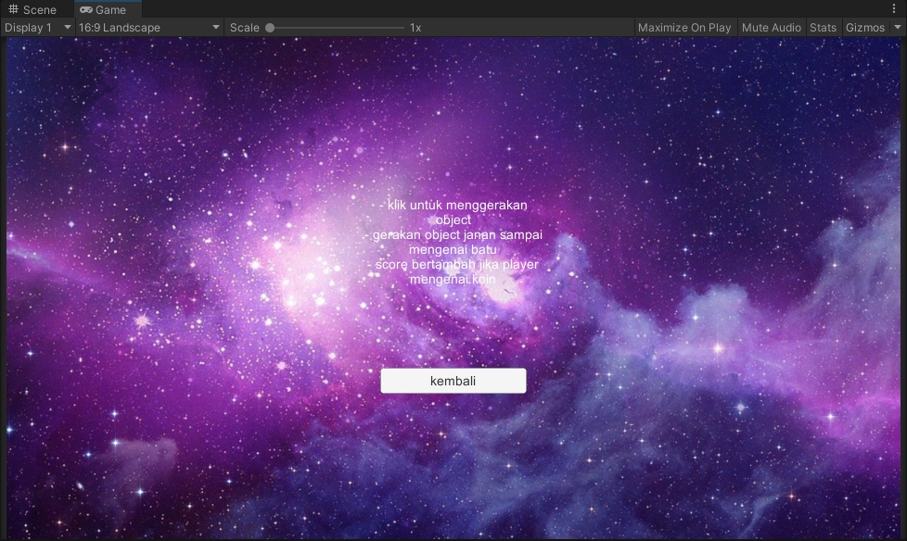

Screenshoot scene help

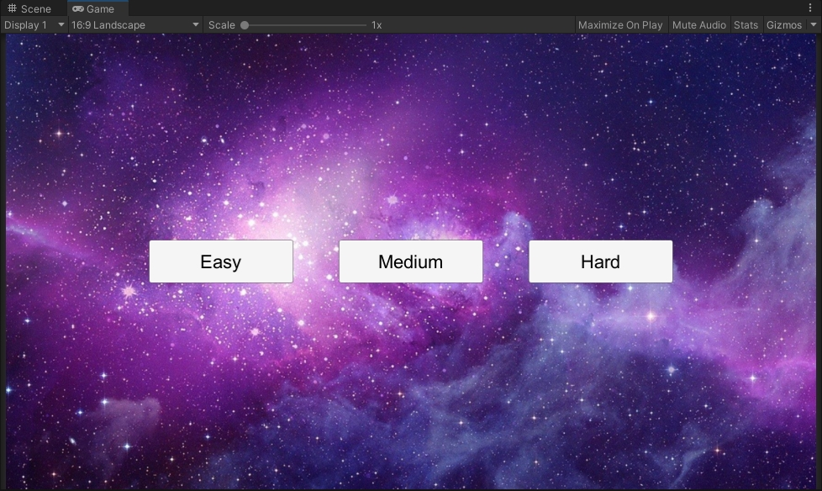

Screenshoot scene level

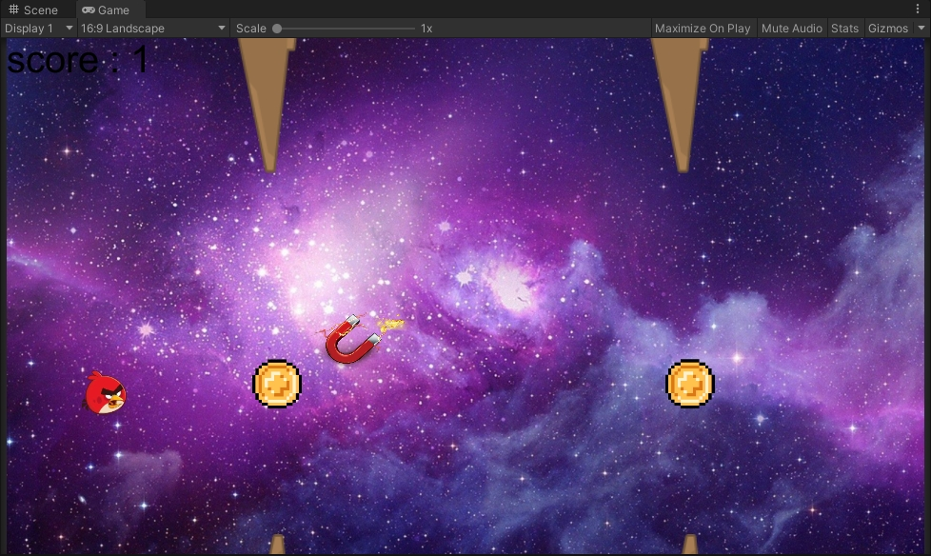

Screenshoot gameplay level easy

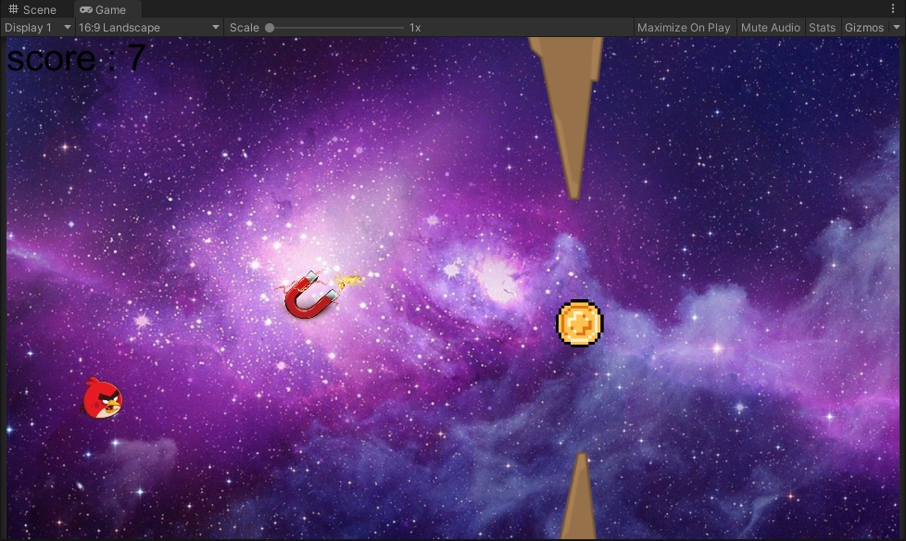

Screenshoot gameplay level medium

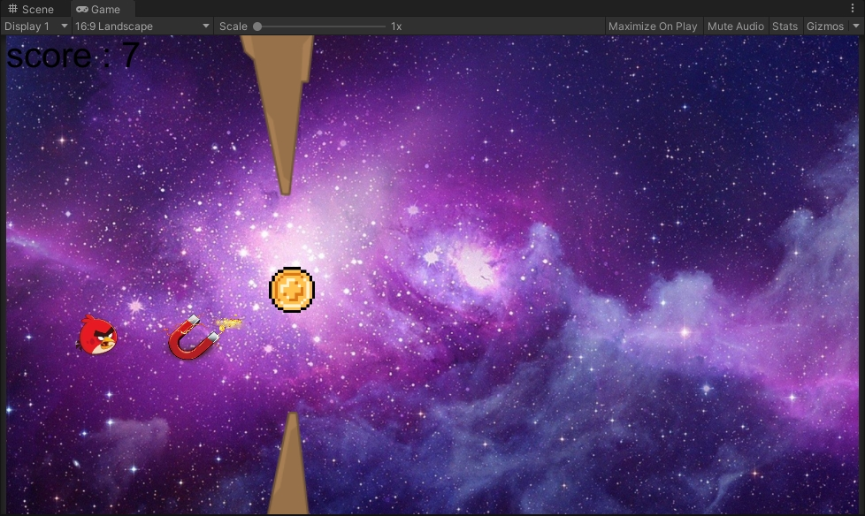

Screenshoot gameplay level hard

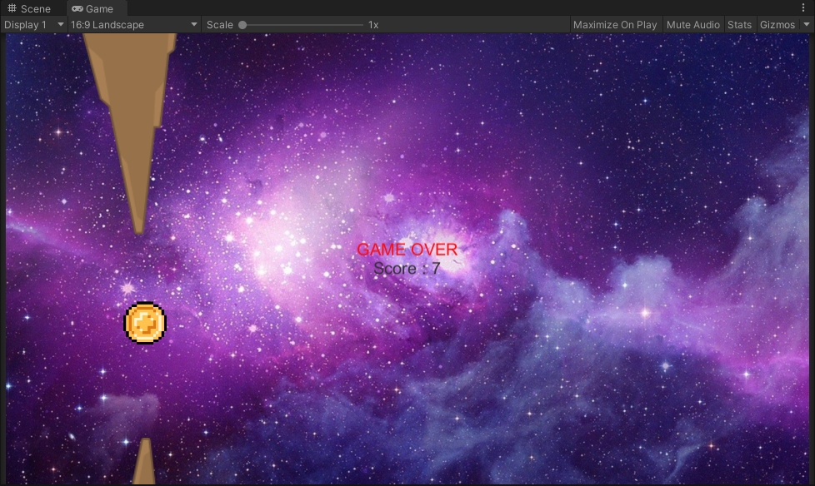

Screenshoot tampilan saat game over

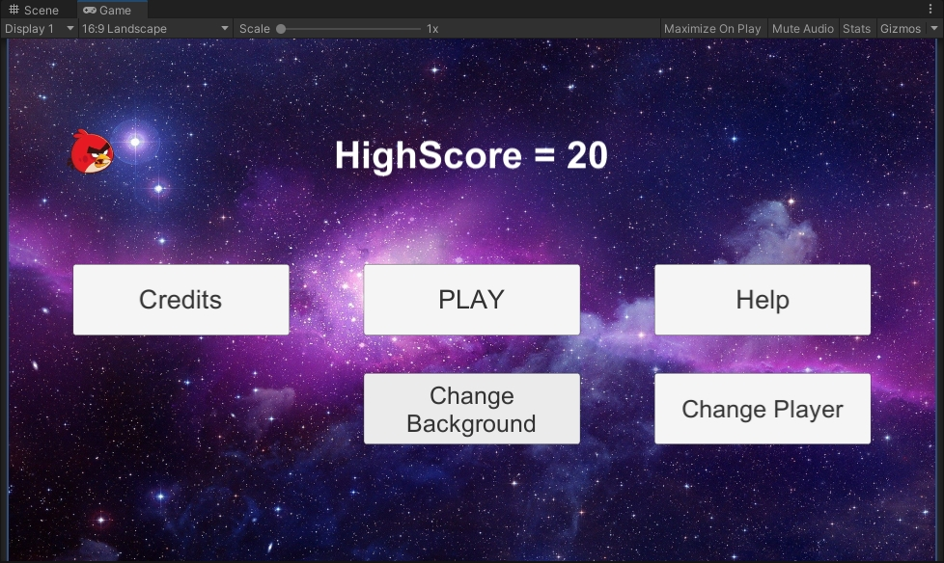

Screenshoot tampilan awal setelah game dimainkan beberapa kali

# BAB III

# Referensi

Dalam pengembangan game ini terdapat beberapa referensi dari berbagai sumber, seperti berikut ini:

1. Referensi untuk fitur merubah background https://www.youtube.com/watch?v=UuDw7qB2_5Q
2. Referensi penambahan object ke array untuk pengaturan background dan player <https://www.youtube.com/watch?v=rdvyelwSnLM>
3. Sumber download background:

<https://wallpaperaccess.com/galaxy>,

<https://wallpaperaccess.com/castle-in-the-sky>,

<https://vistapointe.net/cliff.html>,

<https://wallpapercave.com/w/0ITwf1Z>

1. Referensi cara pengambilan nilai dengan DontDestroyOnLoad <https://pretagteam.com/question/int-variable-resetting-when-loading-another-scene-in-unity>
2. Referensi pembuatan prefabs magnetpoint dari praktikum pertemuan 4
3. Sumber download gambar magnet <https://www.pngwing.com/en/free-png-bqabl>
4. Referensi pembuatan highscore <https://unitycsharp.blogspot.com/2016/03/unity-c-tutorial-indonesia-basic-28.html>
5. Sumber download gambar player:

Angry bird <https://www.pngaaa.com/detail/3647758>

Naruto <https://www.pngaaa.com/detail/170049>

Pacman <https://www.pngaaa.com/detail/2622412>

Sonic <https://www.pngaaa.com/detail/1915586>

Mulut <https://www.pngaaa.com/detail/809387>

Celengan <https://www.pngaaa.com/detail/24438>